Robby Day
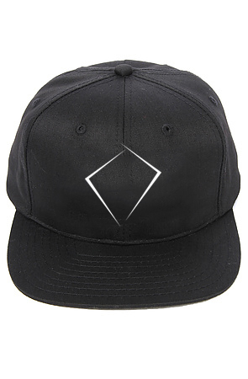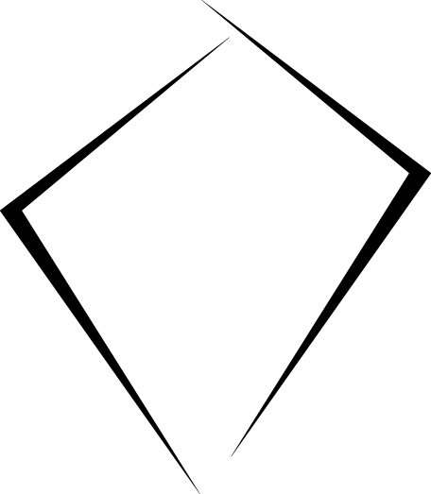

Digitizing (charge one time):
- for front will be Free for regular embroidery and $15 - if 3D
- back embroidery - $25

Embroidery services (per items):
- front , regular - $1.5, If 3D – $3,
- back embroidery -$3

So, If you need to do 36 caps, total amount well be $187, or 256 this 3D embroidery.

